Document Number | RP3
Document Title | Cancellation
Department Ownership | Reception
Document Type | Procedure
Department Owner | Alysia Harper and Angela Di Pardo
Document Author | Alysia Harper and Angela Di Pardo
Last Edited By | Derrick Chan | Lasted Edited On | 07/04/2015

Purpose

The Purpose of this Procedure is to demonstrate the appropriate steps to follow when canceling and appointment

Scope

For all staff at the Health screening Reception

Reference Documents

Definitions

Flowcharts (Other Images)

Procedures

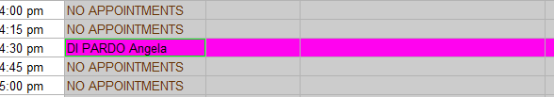
- To cancel an appointment in genie you will first need to locate the patient’s appointment in Genie. Once you have selected the patient’s name you need to right click with the mouse this will cause a window to appear.

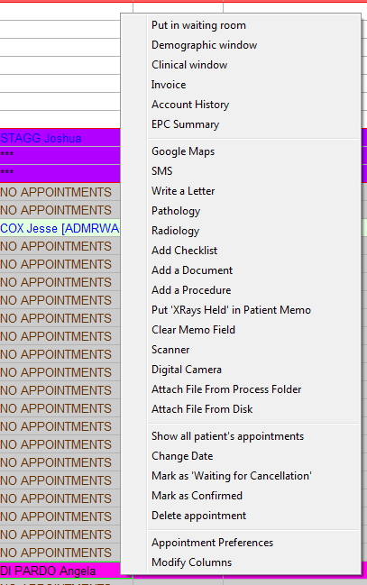
- Once this window appears select “delete appointment” options which is the 3rd option on the toolbar.

- A New window will appear. There are multiple actions to be selected depending on the situation. For example if the candidate did not arrive you will need to select “did not arrive”
NOTE: You are able to add notes into the box below. This is essential for a situation when the company cancel’s an appointment as we can select cancelled by patient but then edit the description such as:

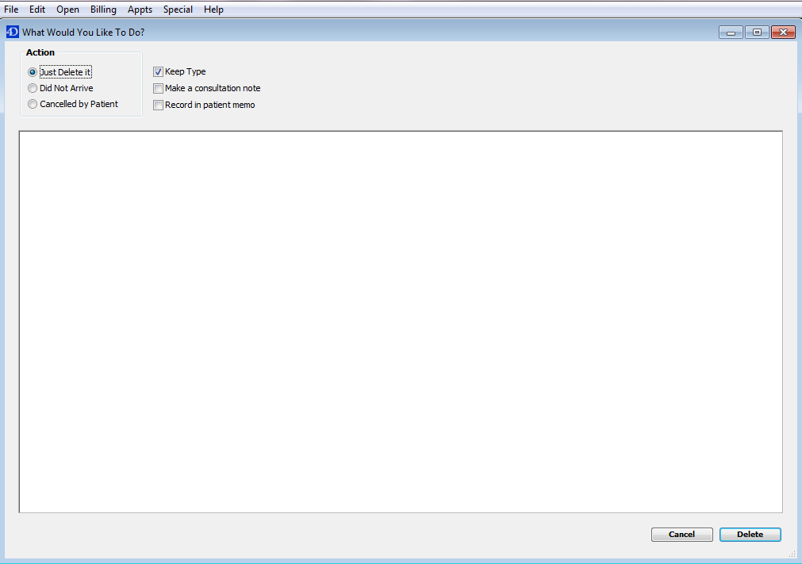

Cancelled by Emilia from BGC on 6/11/13 – charge 100%

- Select Delete.

- The windows will close and you will be bought back to the original page this time with the deleted note in the comments box.

- To complete the process the candidate’s booking from needs to be scanned and linked (follow linking procedure) into genie as well as being billed (follow billing procedure) so that accounts can produce the invoice.

NOTE: For all appointments being charged for any of the above situations the code DNACAN needs to be selected as message will appear on the company’s invoice notifying them of why the full charge has been applied.

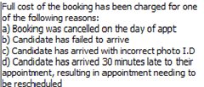

Appendices

